**Curriculum vitae**

|  |
| --- |
|  |
|  |

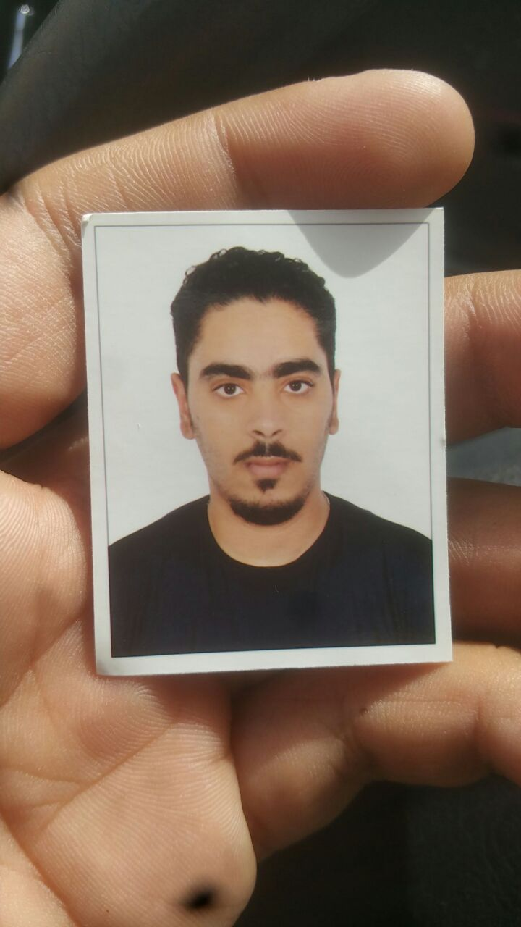**Personal Information:**

Name: Hussain makki ebrahim makki

CPR No.: 950904309

Nationality: Bahraini

Live : Hamad Town

Date of birth: 13-9-1995

Marital Status : Single

Telephone no.: 36577454 - 39142032

Email: bu3looy.king.17@gmail.com‏

**Objective:**

To obtain a position that suit my qualification and capabilities , and to gain excellent experiences and skills from your estimate organization to enhance my future.

**Education & Qualifications:**

**2015 | Al-Jabiriya Secondary School**

* Industrial Track - Electricity / Grade : 81.0 %

**Languages:**

* Arabic : Excellent – speaking & writing.
* English: Good – speaking & writing.

**Skills:**

* **Computer Skills:**
* Windows.
* Microsoft office.
* Searching through the Internet .
* I use the program Word and Excel .

**Interpersonal Skills:**

* Commitment
* Communication skills
* Negotiation
* Flexibility
* Ability to learn fast

**Hobbies:**

* Computer and Internet.
* Draw
* football